|  |
| --- |
| D.J. SANGHVI COLLEGE OF ENGINEERING |
| OOPM Mini Project Report - CANTEEN MENU |
|  |

|  |
| --- |
|  |

**AIM:**

To implement a fully functioning **Online Canteen Menu for Students** using Java language.

Software used: Netbeans IDE and Derby Database using SQL Commands.

**THEORY:**

*SIGN-UP*

*EXIT*

*BILLING*

*MENU*

*WELCOME*

*LOGIN*

* JForm1 – WELCOME

This first page of GUI gives the user an option to either create a new account or login into an existing account.

* JForm2 – SIGNUP

This page comprises of the create account page which enables the user to enter his or her details like: SAP-ID, PASSWORD & WALLET AMMOUNT. These entered values are inserted and saved into the database.

* JForm3 – LOGIN

This page enables the user to enter their details just like the SIGNUP page. If the entered values match the database values, only then can the user proceed to the next page – MENU.

* JForm4 – MENU

This page consists of a number of food items which can be ordered as desired by the user.

In order to select the required food item, the user has to click on the image corresponding to select the food item. The user can also reset the order if required. After user is satisfied with their order they can confirm their order, which in turn updates the WALLET column.

* JForm5 – BILLING

This page simply prints the wallet balance, bill amount & if wallet balance is zero, the

amount to be payed.

**CONCLUSION:**

Thus we have successfully implemented a canteen menu for students.

**OUTPUT:**

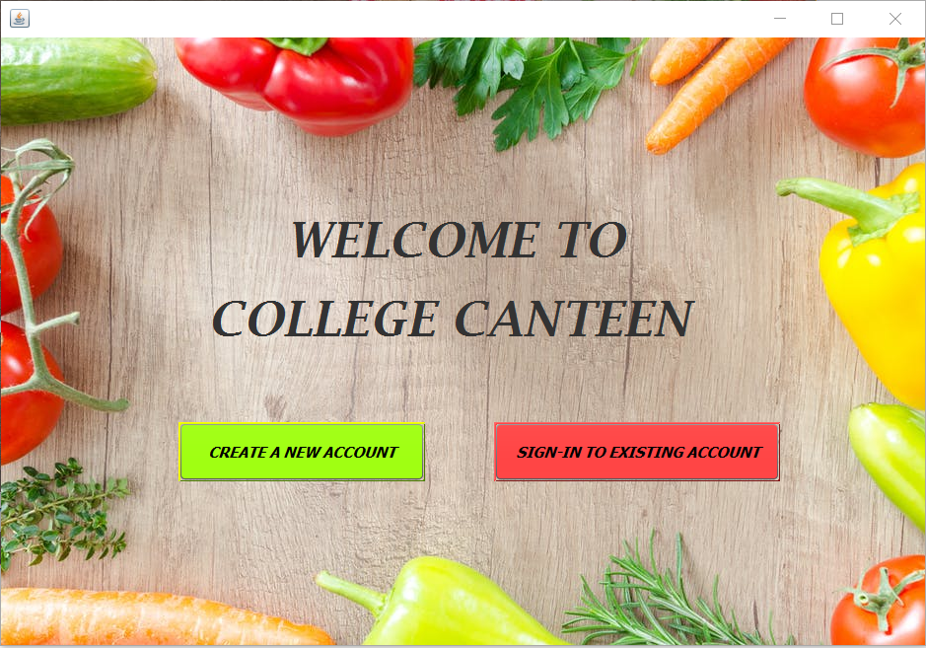

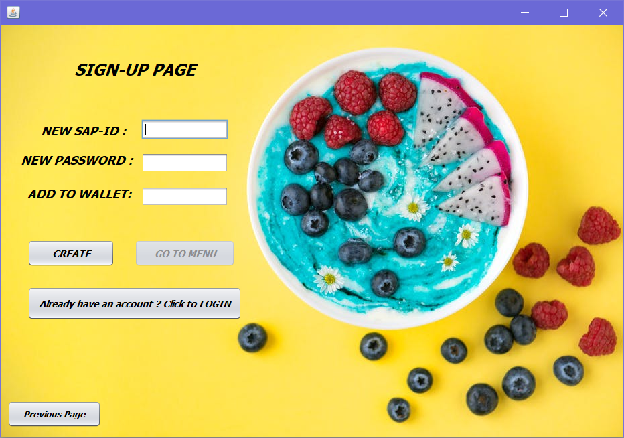

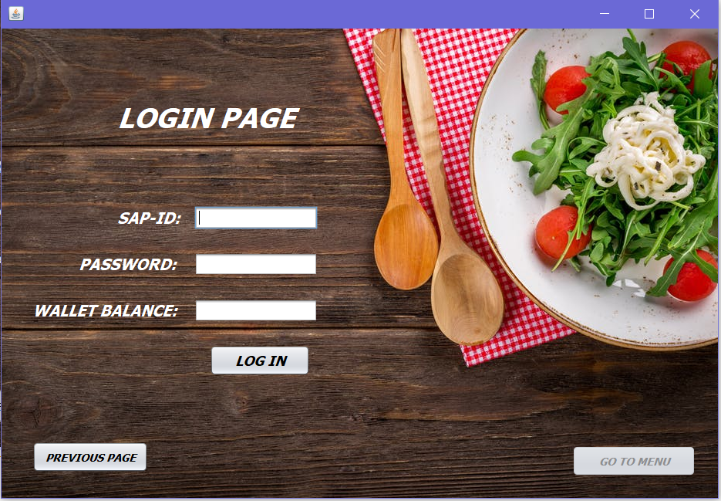

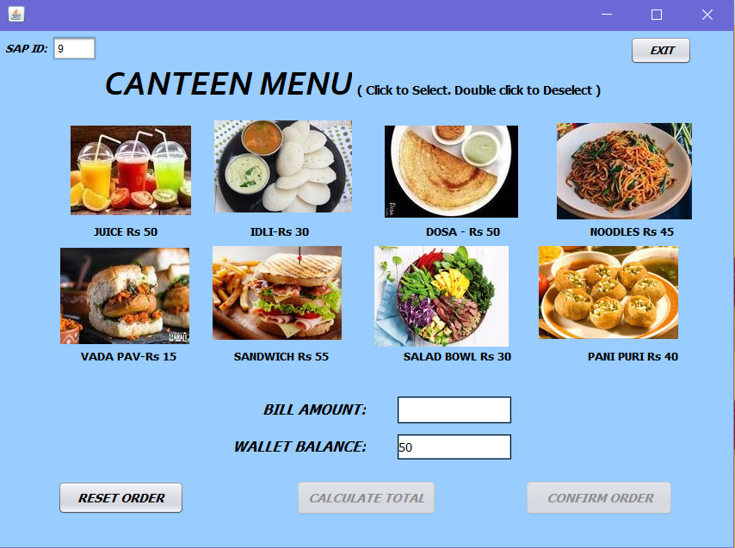

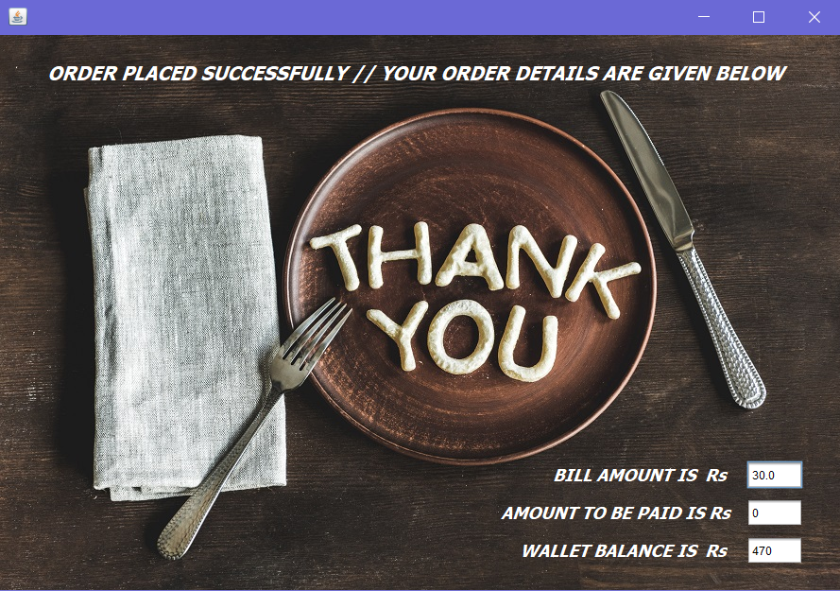

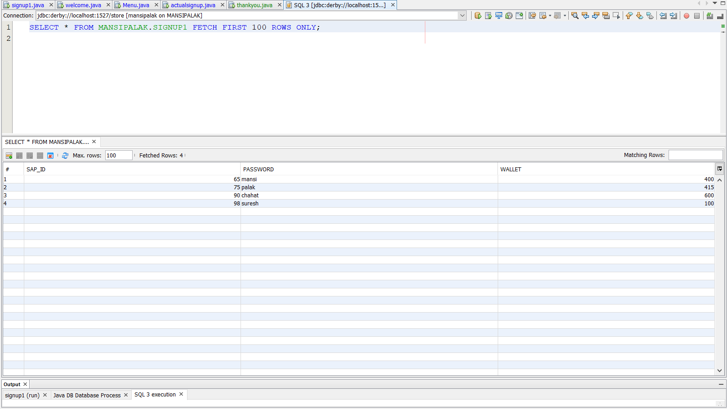

**NAME AND SAP ID:**

* **MANSI PANDYA - 60004170065**
* **PALAK CHAVAN - 60004170075**